**ASSIGNMENT 2**

**Roll no – A-44**

**Code –**

import pandas as pd

import seaborn as sns

import matplotlib.pyplot as plt

sales_data = {

    'Date' : ['1-2-23', '2-2-23', '3-2-23', '4-2-23', '5-2-23', '6-2-23'],

    'Sales' : [5000, 4800, 5200, 4500, 4700, 5000],

    'Expenses' : [1000, 1000, 1200, 500, 700, 900],

    'Profit' : [4000, 3800, 4000, 4000, 4000, 4100]

}

df = pd.DataFrame( sales_data)

print(df.describe) # Statistical measures

# Data visualization

sns.set_style("darkgrid")

plt.figure(figsize=(10,6))

sns.lineplot(x="Date", y="Sales", data=df, label="Sales")

sns.lineplot(x="Date", y="Expenses", data=df, label="Expenses")

plt.xlabel("Date")

plt.ylabel("Amount")

plt.title("Sales vs. Expenses")

plt.legend()

plt.grid(True)

plt.show()

plt.figure(figsize=(8,6))

sns.barplot(x="Date", y="Profit", data=df)

plt.xlabel("Date")

plt.ylabel("Profit")

plt.title("Monthly Profit")

plt.grid(axis='y')

plt.show()

print("Data analysis Completed.")

**Output-**

**Date Sales Expenses Profit**

**0 1-2-23 5000 1000 4000**

**1 2-2-23 4800 1000 3800**

**2 3-2-23 5200 1200 4000**

**3 4-2-23 4500 500 4000**

**4 5-2-23 4700 700 4000**

**5 6-2-23 5000 900 4100**

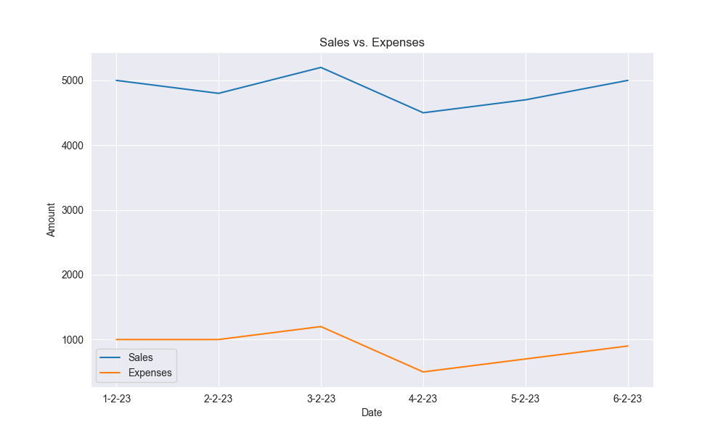**Data analysis Completed.**

